
Cairo University Faculty of Engineering
Computer Engineering Department

CMPS458 Reinforcement Learning Report

Team18:

Loay Ahmed Kamal Abdelghafar Othman 1210412

Mohamed Mamdouh Sayed Mohamed Elsemary 1210416

Supervisor: Ayman AboElhassan

November 13, 2025

Repo Link
Experiments:
Acrobot:
We found that the best was with gamma 0.99 and epsilon decay 2000. Then we ran different learning rates, replay memory and batch sizes. We ran lr = 0.001, 0.0001, memory_size = 2000, 10000 and batch_size = 32, 128.
We ran 2000 episodes so in general all the models achieved the goal, but in general the DQN models with high memory size, batch size and learning rate performed best. The duration wasn’t much different in training between DDQN and DQN.
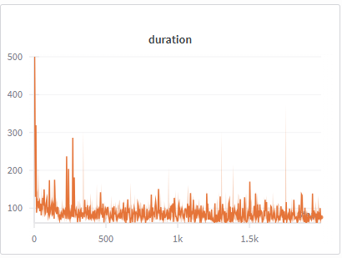
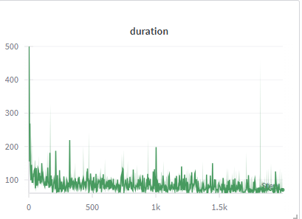
Figure 1 DDQN Duration
Figure 2 DQN Duration
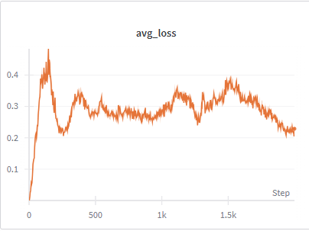
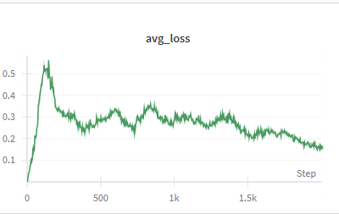
But, during the testing we got avg duration 69.97 in DDQN and 68.70 in DQN with the same parameters. But the std was less in the DQN which is about 5
Also loss was a bit lower at the end in the DQN,
Figure 3 DDQN loss
Figure 4 DQN Loss

CartPole:
We found that the best was with gamma 0.99 and epsilon decay 2000. Then we ran different learning rates, replay memory and batch sizes. We ran lr = 0.001, 0.0001, memory_size = 2000, 10000 and batch_size = 32, 128.
Here we only ran 500 episodes and the lowest duration we got on the tests was with the DQN at the high memory size and learning rate with was average 83 (with std deviation 6) which is nearly half of when we ran DDQN which was around 148. The loss we got in the DQN model was as follows:
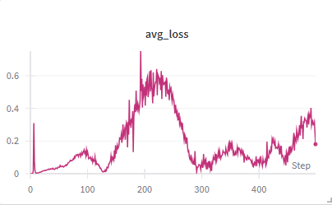
Figure 5 DQN Loss
Mountain Car:
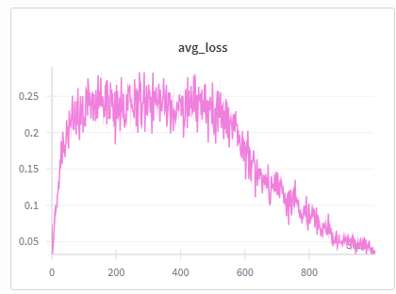
Here we ran 1000 episodes and ran different learning rate(0.001, 0.0005) epsilon decay(5000,20000), memory size and batch size. We found that it best at slow decay (20000) and memory size 50000 and batch size 128 with gamma 0.98 . The DQN and DDQN were pretty similar with these parameters with test duration 100 and 103 respectively. The loss also was similar:
Figure 6 DQN Loss

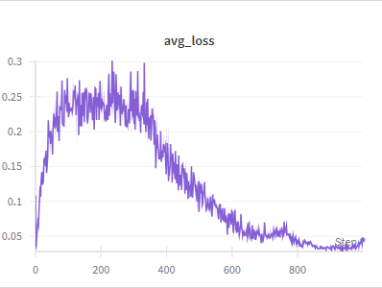
Figure 7 DDQN Loss
Pendulum:
We ran 500 episodes. We ran with gamma 0.99 and memory size 6000 and changed the batch size and learning rate. Performance is expected to be very poor. The agent lacks the fine-grained control to balance the pendulum and can only "slam" the controls. The agent lacks fine-grained control. Because its action space was binned into 5 discrete choices, it can only "slam" the controls (e.g., -2.0, -1.0, 0.0, 1.0, 2.0). This crude approach is ineffective, as it will constantly overshoot the target, failing to build the necessary momentum for the swing-up and making stabilization at the top impossible.

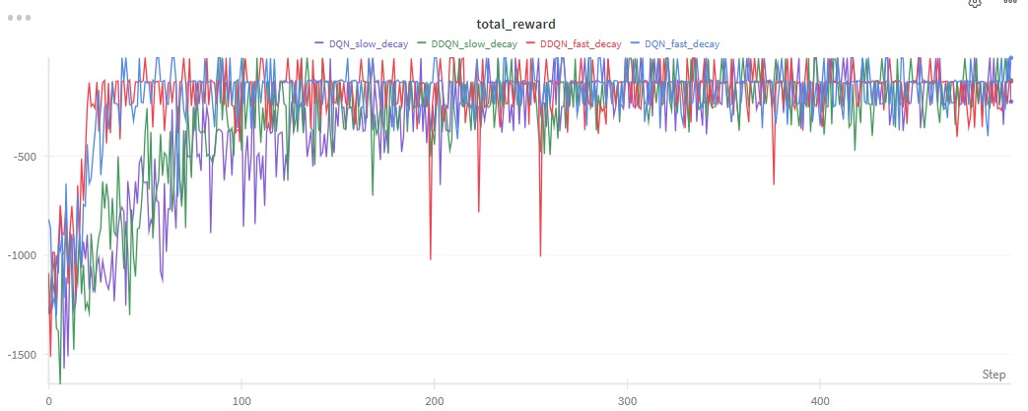
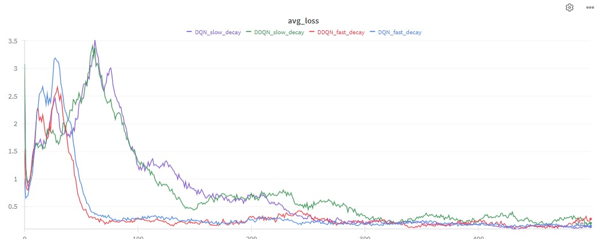
Figure 8: Avg Loss
Figure 9: Total Reward
- DQN vs. DDQN
- Training Time: Almost identical in wall-clock time, but DDQN learns faster (is more sample-efficient) and its training curve is more stable.
- Performance: DDQN usually has better final performance because it fixes DQN's tendency to overestimate Q-values, leading to a more accurate policy.
- How stable are the agents?
- Look at the test_std_duration (or test_std_reward) in your wandb logs. A low standard deviation means the agent is stable.
- A stable agent's histogram will be tall and narrow.an unstable one will be short and wide. All shown in the run console of the notebook.

- Effect of hyper parameters
- Lower Learning Rate (e.g., 0.0001): Slower training, but often leads to a more stable and higher final performance.
- Higher Epsilon Decay (e.g., 2000): Agent explores for longer. This can be good for complex problems (like Acrobot) but may slow down learning on simple ones (like CartPole).
- Lower Gamma (e.g., 0.95): Makes the agent more "short-sighted" (cares less about future rewards). This is usually bad for problems that require long-term planning.

- How well-suited is DQN/DDQN?
- CartPole: Perfectly suited. A classic, simple problem with discrete actions that DQN solves easily.
- MountainCar: Poorly suited on its own (due to sparse rewards), but well-suited with the reward shaping (the +100 bonus) you added.
- Acrobot: Moderately suited. It works, but the complex physics makes it hard for the agent to get high scores.
- Pendulum: Fundamentally unsuited. The original problem has continuous actions. Your discretizing wrapper makes it work, but the performance will be very poor, proving that DQN is the wrong algorithm for this problem.

